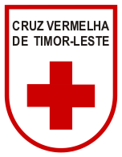
CRUZ VERMELHA DE TIMOR-LESTE
Rua Cristo Rei s/n, Bidau Santa-Ana Tel +670 3321688 Fax +670 3321688 Website: www.redcross.tl

Dili, Timor-Leste
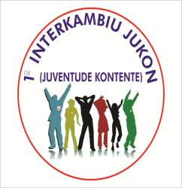

Programme For National Youth and Volunteer Camp (JUKON) Cruz Vermelha de Timor – Leste
8th to 11th June 2016, Eraulu Village , Ermera District, Timor-Leste

Date  Time | 8 June 2016 | 9 June 2016 | 10 June 2016 | 11 June 2016 | 12 June 2016
07.00-08.00 | Breakfast | Breakfast | Breakfast | Breakfast | Breakfast
08.00-09.00 | Registration | Opening Ceremony | Workshop : First Aid, CBHFA, DM, Healthy Youth, Public Speaking, Fundamental Principal, Child Protection, Peace and Conflict,Climate Change, Leadership, Fundraising, Livelihood, HIV/Aids. | Service : Physical and Non Physical Activities | Departure
09.00-10.00
10.00-11.00 |  | Workshop : First Aid, CBHFA, DM, Healthy Youth, Public Speaking, Fundamental Principal, Child Protection, Peace and Conflict,Climate Change, Leadership, Fundraising, Livelihood, HIV/Aids.
11.00-12.00
12.00-13.00 | Lunch | Lunch | Lunch | Lunch
13.00-14.00 | Pre-Preparation | Continue Workshop | Continue Workshop | Simulation Disaster Management
15.00-16.00 |  | Friendship Sports | Friendship Sports
16.00-17.00 |  |  |  | Closing Ceremony
17.00-18.00 |  | Outbound Activities | Outbound Activities
18.00-19.00 | Dinner | Dinner | Dinner | Dinner
19.00-20.00 | Music and Culture dance performance | Music and Culture dance performance | Music and Culture dance performance | Farewell Performance
20.00-21.00

